**Stage 5**

**RULES:** USPSA Competition Rules, Latest Edition **COURSE DESIGNER:** JOHN ROYER - Outdoor Dynamics

|  |  |
| --- | --- |
| **START POSITION: See written stage briefing.** | |
| **STAGE PROCEDURE**  See written stage briefing. | **SCORING**  **SCORING:** Comstock 28 rounds.  **TARGETS:** There are 14 cardboard targets. Best 2 hits will score.  **SCORED HITS:** 2 Best hits per carboard will be scored.  **START-STOP:**  Audible - Last shot  **PENALTIES:** Per USPSA Competition Rules |

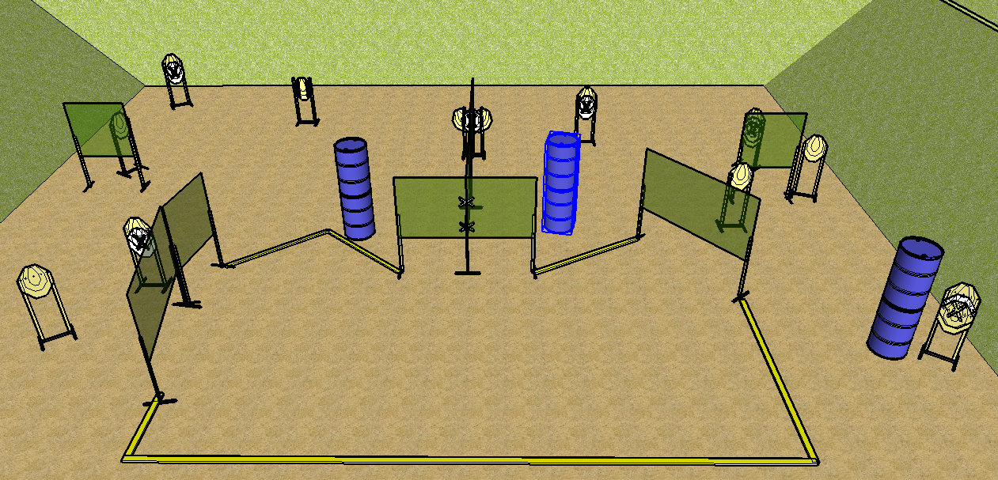

**Written Stage Briefing:**

**Stage 5 –** is a 28-round, 160 point, Comstock Long Course. There are 14 cardboard targets. The best 2 hits per cardboard target will be scored.

**Start position**

Handgun: Hands touching marks, facing downrange. Handgun is loaded and holstered.

PCC: PCC Muzzle touching lower mark, facing downrange. PCC is loaded and held in both hands.

On the audible start signal, engage targets from within the shooting area.

**Setup Notes:**

Be sure to hydrate yourself.